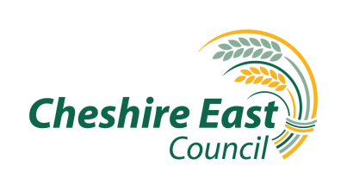 Old Hall Volunteer Role Profile Description
What is an Old Hall Volunteer?
Volunteering at Old Hall is a new opportunity. Volunteers will assist with a variety of task helping prepare old hall and its grounds for visitors, school groups and events. Working with the small Old Hall team they help ensure general upkeep tasks are carried out and events are prepared for, ensuring Old Hall visitors have opportunity to visit this hidden gem at the heart of the Tatton estate. The Old Hall is the oldest surviving building at Tatton with parts dating back to 1490; it was the Manor house until the new Mansion was built in the 18th Century. Set within its own walls in the middle of the estate it is primarily used for school visits and events such as medieval Fayre, Viking days, open air theatre and has a seasonal opening to general visitors throughout the summer.

What’s in it for you?
Being part of a small team helping to preserve and care for the Old Hall grounds
Satisfaction of helping facilitate visitors and school parties access to Old Hall
Opportunity to be involved with event planning and preparation tasks, working with external contractors
Wide variety of task, flexible days to suit

What’s involved?
- General ground maintenance and presentation work such as mowing using a ride on mower and hover mower and use of a strimmer
- preparing logs for fires, pruning and lopping small branches
- Flattening mole hills and rabbit scrapes
- helping set up gazebos and tents for events,
- helping decorate old hall interiors to events such as Halloween
- Be involved in other activities where we could use your help

This role will suit people who….
Enjoy outdoor working as part of a small team carrying out a variety of straightforward manual tasks outdoors and variety

Extra Information
Your Place Tatton Park Old Hall
Time Commitment Flexible

Volunteer Manager
Email Mick Ricketts
Tel: 01625 374432

What your need to wear/
Bring Work clothes, boots and packed lunch

Training/Resources

Expenses Please see Expense Guidance in the Volunteer Handbook

About Tatton Park is one of the North West’s largest attractions, 850,000 visitors per year. The 2,000 acre estate incorporates a diverse range of habitats, landscapes and visitor opportunities. From deer park, SSSI mere and veteran woodland to gardens, a rare breed farm, Tudor Hall, Historic Mansion and large children’s playarea, there really is something for everyone

This role is purely voluntary and this arrangement is not meant to be a legally binding one or an employment contract

